**LAB 8**

1. Write a program that displays your name horizontally in the middle of the screen using display memory.  
  
    a. Write a procedure that on each call shifts your string one row downwards.  
    b. Change your program so that the string keeps on shifting downwards , and whenever the string exits the lower boundary of the screen , it reappears from the top boundary.

**CODE:**

org 100h

.data

n db 'Hashim$'

linecounter db 0

check db 0

.code

main proc

mov bp,(13-1)*160+(38-1)*2

mov si,bp

top1:

call print

call down

cmp linecounter,-1

jne top1

ret

print proc

lea di,n

mov ax,0xb800

mov es,ax

mov cl,6

mov ah,0x07

top:

mov al,[di]

mov es:si,ax

inc di

add si,2

loop top

ret

down proc

xor dx,dx

mov dx,(25-1)*160+(38-1)*2

cmp bp,dx

jl adding

mov bp,(1-1)*160+(38-1)*2

mov bl,1

adding:

add bp,160

mov si,bp

mov ah,6

mov al,0

mov ch,0

mov cl,0

mov dh,24

mov dl,79

mov bh,7

int 10h

ret

**OUTPUT:**

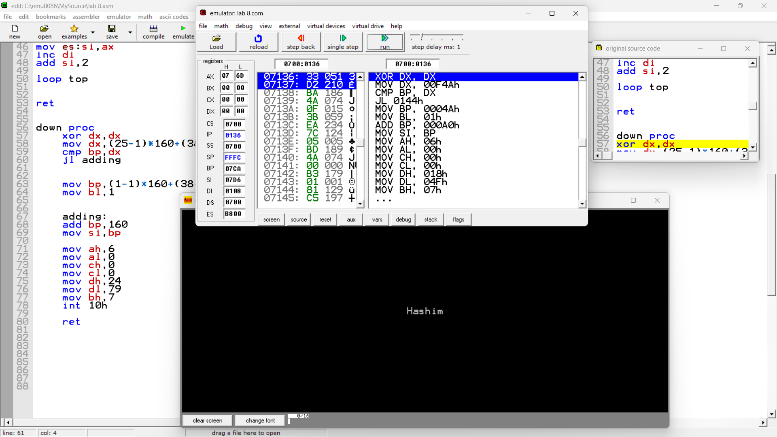

2. Write a program that displays your name vertically in the middle of the screen using display memory.  
    a. Write a procedure that on each call shifts your string one column to the right.  
    b. Change your program so that the string keeps on shifting right, and

whenever the string exits the right boundary of the screen, it reappears from the left boundary.

**CODE:**

org 100h

.data

n db 'Hashim$'

linecounter db 0

check db 0

.code

main proc

mov bp,(10-1)*160+(38-1)*2

mov si,bp

top1:

call print

call right

cmp linecounter,-1

jne top1

ret

print proc

lea di,n

mov ax,0xb800

mov es,ax

mov cl,6

mov ah,0x07

top:

mov al,[di]

mov es:si,ax

ADD si,158

inc di

add si,2

loop top

ret

right proc

xor dx,dx

mov dx,(10-1)*160+(80-1)*2

cmp bp,dx

jl adding

mov bp,(10-1)*160+(1-1)*2

mov bl,1

adding:

add bp,2

mov si,bp

mov ah,6

mov al,0

mov ch,0

mov cl,0

mov dh,24

mov dl,79

mov bh,7

int 10h

ret

**OUTPUT:**

